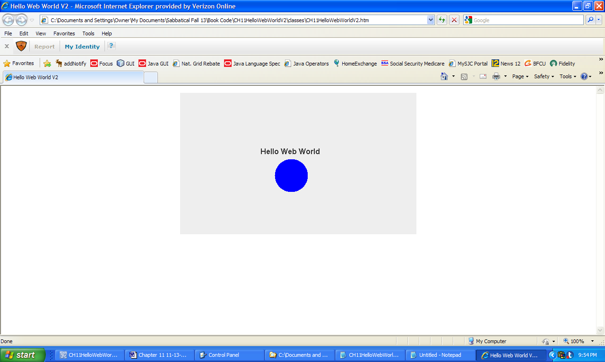

**Figure 11.46 The web page containing the applet HelloWebWorldV2.**